Lab 15: SNS, SQS, and SES Integration
(Send notifications, trigger workflows, send emails)

Step 1: Create SNS Topic (Notification Hub)
I started by creating an SNS topic to send notifications.
- Navigated to: AWS Console → SNS → Topics → Create topic
- Selected: FIFO
- Name: Lab15-Topic
- Display name: Lab15 (optional)
- Encryption: Disabled
- Access policy: Default
After creating the topic, I copied the Topic ARN for later use.
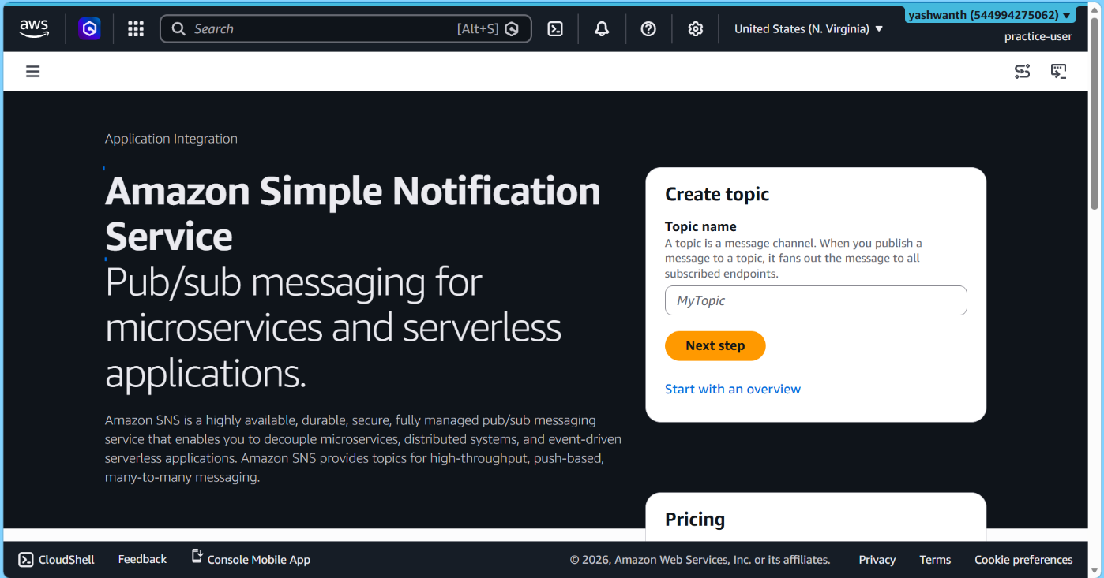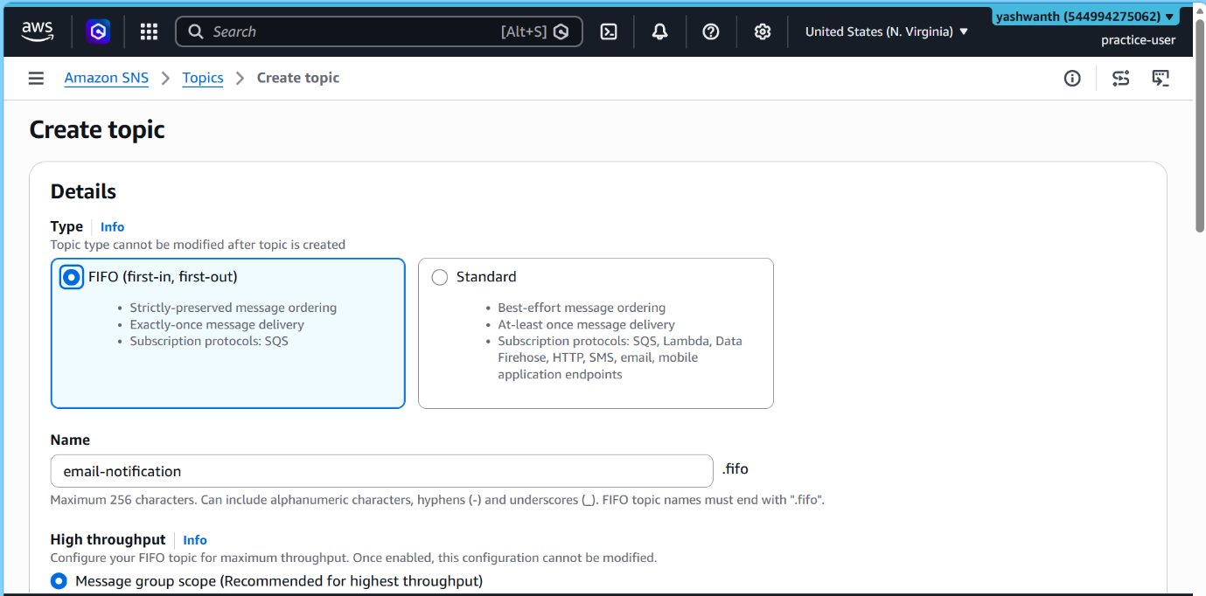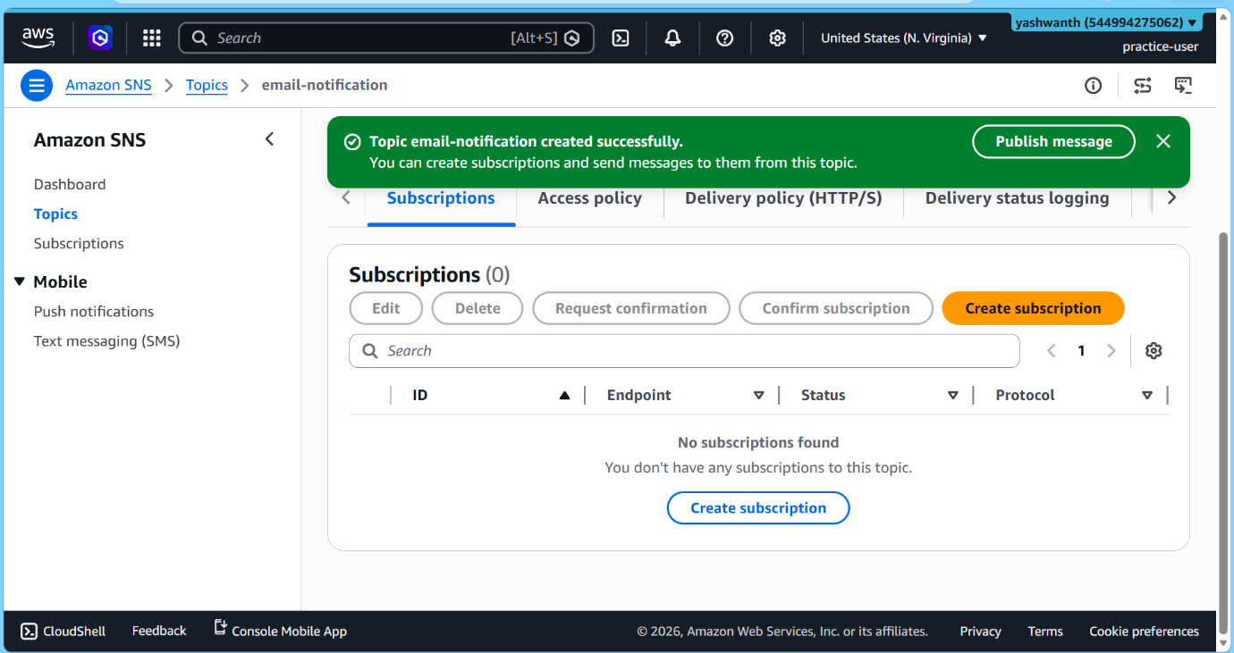

Step 2: Create SQS Queue (Message Storage)
Next, I created an SQS queue to store messages.
- Navigated to: AWS Console → SQS → Create queue
- Queue type: Standard
- Name: Lab15-Queue
- Visibility timeout: 30 seconds
- Message retention: 4 days
- Delivery delay: 0
After creation, I copied the Queue ARN.

Step 3: Configure SNS to SQS Integration
I then allowed SNS to send messages to SQS and connected both services.
Give Permission (SNS → SQS)
- Went to: SQS → Lab15-Queue → Permissions → Edit
- Updated policy using:
  - QUEUE_ARN
  - SNS_TOPIC_ARN
  - Now SNS is authorized to send messages to SQS.
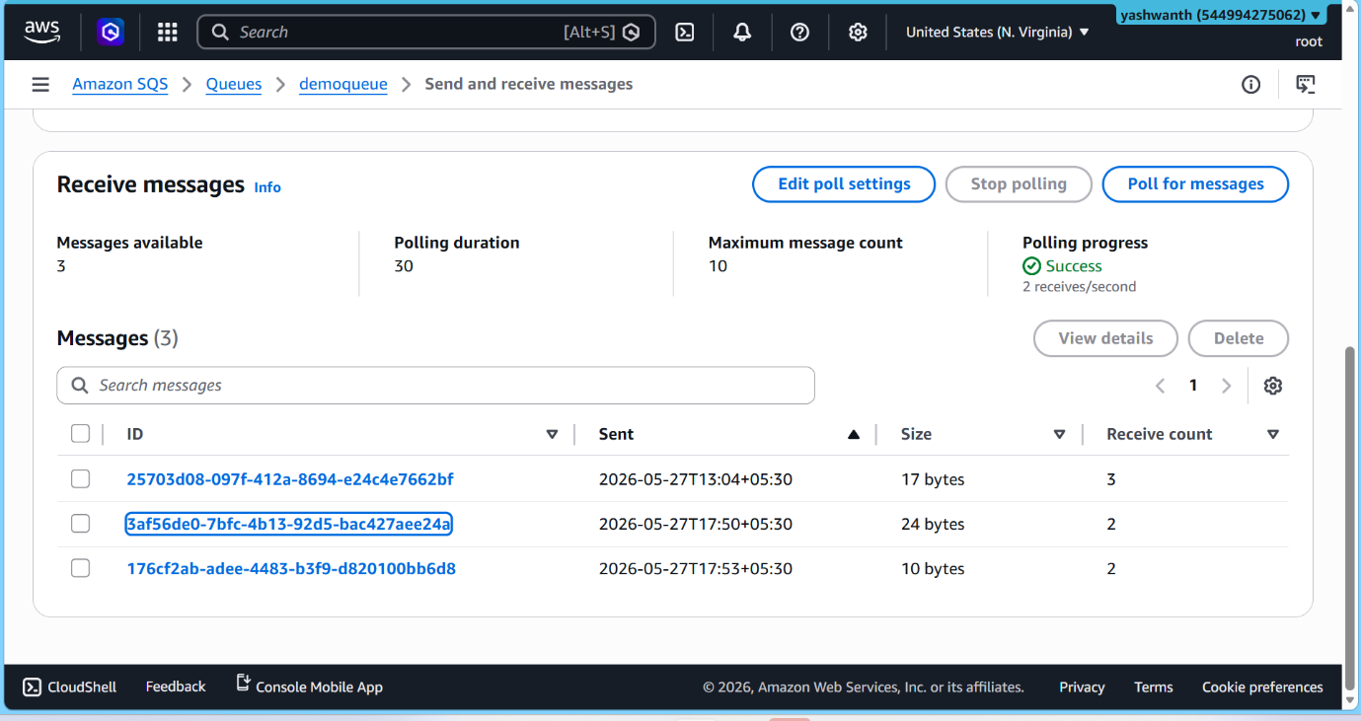
Create Subscription (SQS)
- Went to: SNS → Topics → Lab15-Topic
- Clicked: Create subscription
- Protocol: Amazon SQS
- Endpoint: Pasted SQS Queue ARN
- Raw message delivery: Disabled
Subscription status is Confirmed
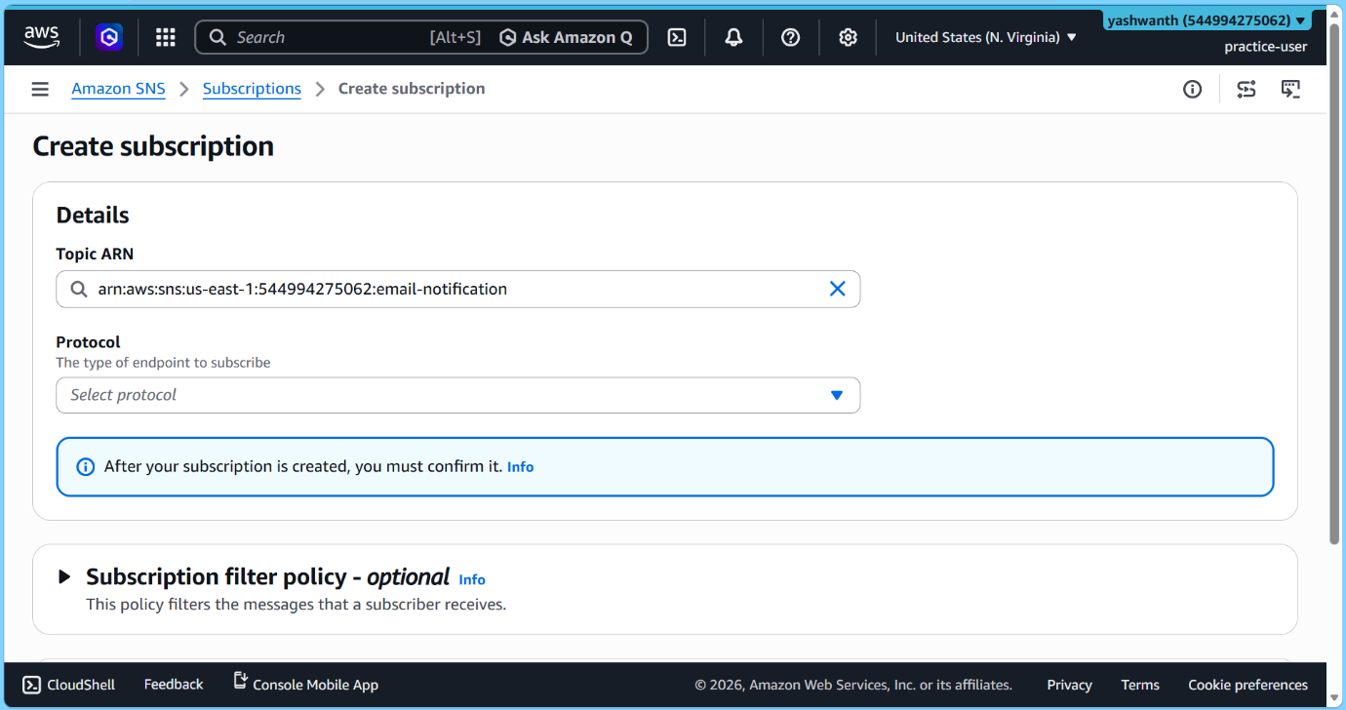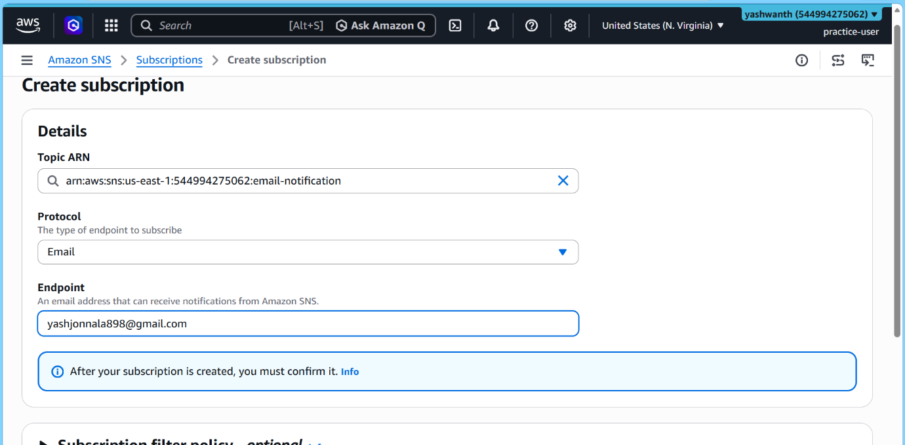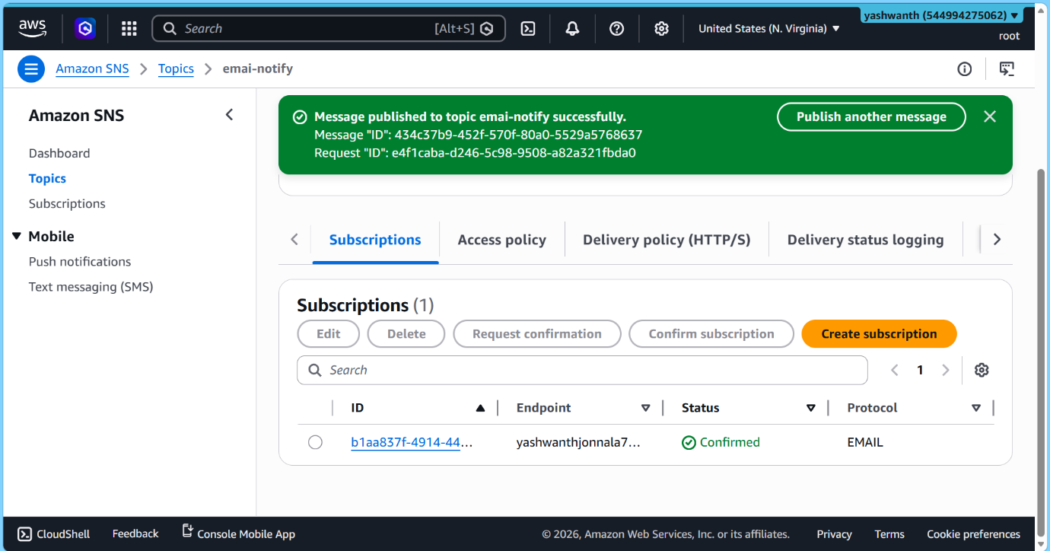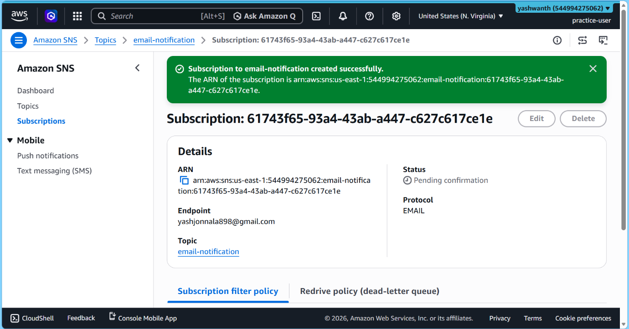

Step 4: Add Email Notifications (SNS)
To receive alerts via email, I added an email subscription.
- In SNS topic → Clicked Create subscription
- Protocol: Email
- Endpoint: my email address
- Clicked Create subscription
I then opened my email and confirmed the subscription.
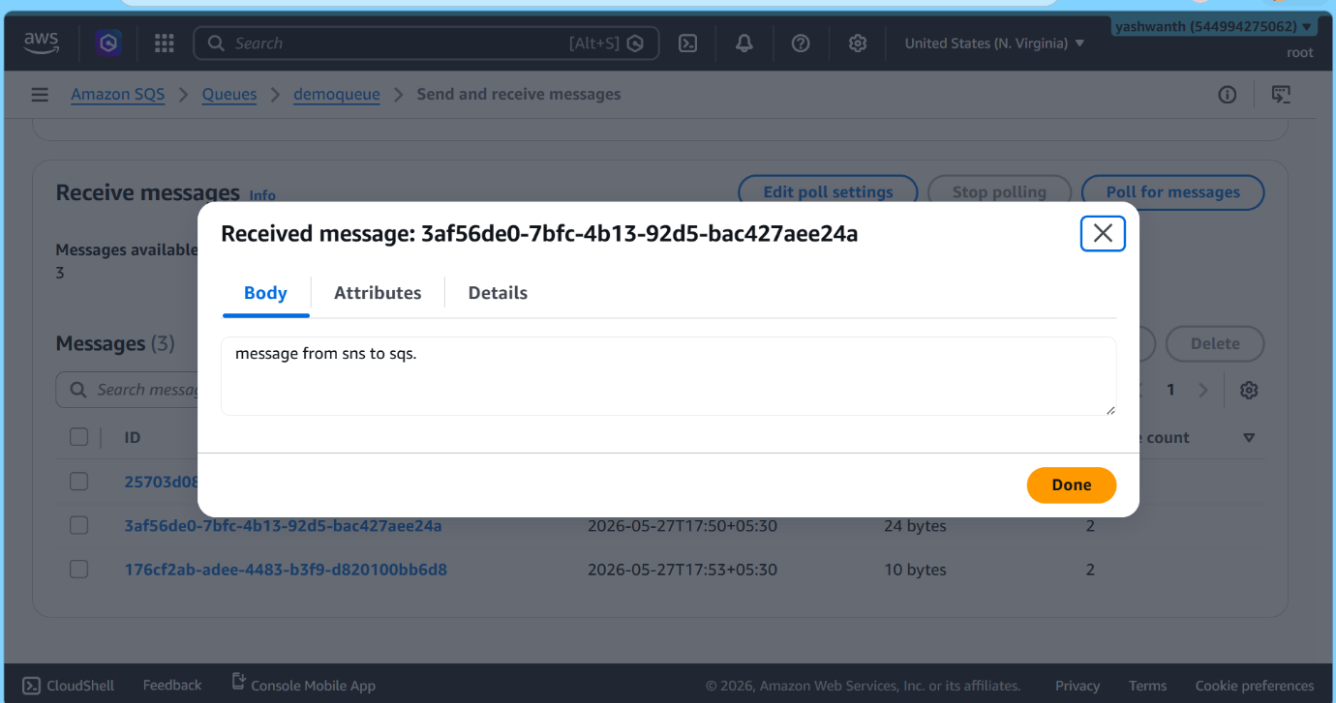

Step 5: Configure SES (Email Service)
Verify Email Identity
- Navigated to: SES → Verified identities → Create identity
- Identity type: Email
- Entered my email address
- Clicked Create identity
I verified the identity using the email link.
Status changed to Verified
Check SES Mode
- Went to: SES → Account dashboard
- Confirmed: Sandbox mode is enabled
This means emails can only be sent to verified addresses.
Send Test Email
- Went to: SES → Identities
- Selected my verified email
- Clicked Send test email
- Details:
  - From: My email
  - To: My email
  - Type: Formatted
  - Subject: Lab15 SES Test
  - Body: Hello, This is a test email from SES.
Successfully received the test email.


Step 6: Test End-to-End Flow (SNS → SQS → Email)
Publish Message via SNS
- Navigated to: SNS → Topics → Lab15-Topic → Publish message
- Subject: Lab15 Notification
- Message: SNS → SQS → SES integration successful
- Clicked Publish
Verify Results
Email Check:
- Received SNS notification email
SQS Queue Check:
- Navigated to: SQS → Lab15-Queue → Send and receive messages
- Clicked Poll for messages
Sample message received:
{
"Type": "Notification",
"Message": "SNS → SQS → SES integration successful"
}
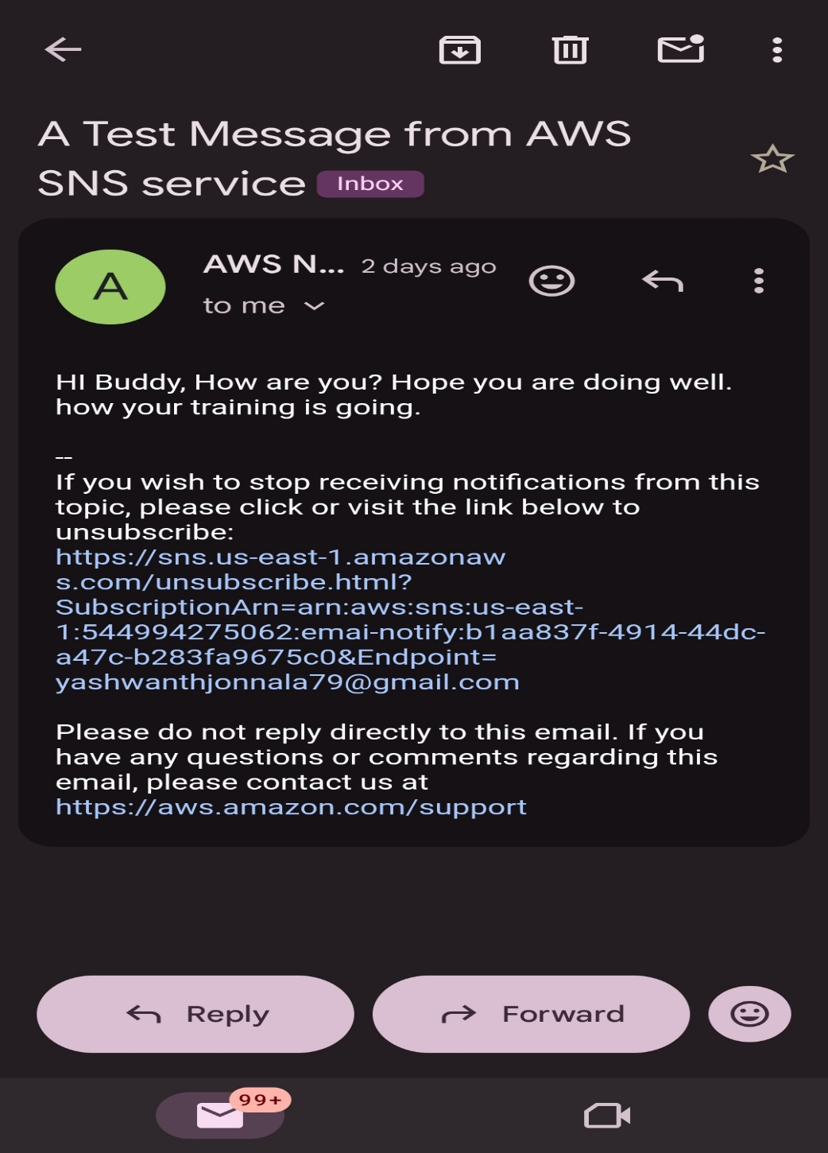

Conclusion
In this lab, I successfully:
- Created SNS topic for notifications
- Integrated SQS for message storage
- Configured SES for email sending
- Verified complete workflow:SNS → SQS → Email notification

